Low-Level Design (LLD) — Service Log Capture Module
Attribute | Value
Module | Service Log Capture
Menu path | After Market → Service Log Capture
Application | Complaint / Dealer Portal (After Market)
Stack (target) | Core PHP + MySQL (PDO)
Stack (current repo) | Core PHP + PostgreSQL via PDO (pdo_obconn.php) — schema maps 1:1 to MySQL
Document version | 1.0
Related modules | Installed Base Capture, Spare Parts Consumption, Complaints (Service Update), RBAC

────────────────────────────────

1. Module Overview

1.1 Purpose
Service Log Capture records a field service visit against an existing Installed Base machine: issue description, engineer, visit/closure dates, warranty type, part replacement (optional multi-line parts), running hours, customer feedback, and remaining consumable life. It supports draft and final (completed) states, and is a parent link for Spare Parts Consumption and for Complaint Service Update cycles.

1.2 Scope
In scope | Out of scope
Create / update / soft-delete service logs | Hard delete / cascade to spare parts
Draft save and promote to final submit | Changing RBAC admin UI
Server-side DataTable listing with after-market scope | Order booking (Order ID hidden; saved as 0)
Link to Installed Base (FAB / machine model from IB) | Inventory / pricing of spare kits
Part-replaced multi entries + remaining consumables | Full ERP sync
Launch Add Spare Parts from SL row | Installed Base master CRUD (separate module)
Create/draft from IB modal and Complaint Service Update modal

1.3 High-level architecture
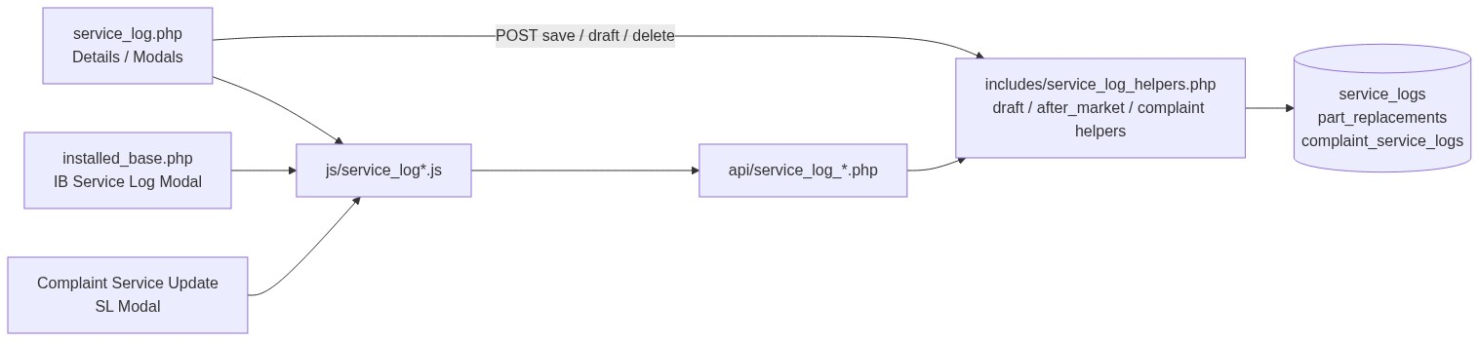
Figure 1 — High-level architecture
────────────────────────────────

2. Functional Requirements
ID | Requirement | Priority
FR-01 | Users with view can open listing and details | Must
FR-02 | Users with add (or IB add-service-log-capture) can create service logs | Must
FR-03 | Users with edit can update accessible records | Must
FR-04 | Users with delete can soft-delete accessible records | Must
FR-05 | Listing is server-side searchable/sortable (DataTables) with draft badge | Must
FR-06 | Service log requires an existing accessible Installed Base | Must
FR-07 | Fab Number must match the selected Installed Base FAB | Must
FR-08 | Serial number auto-allocated (10001–99999), read-only, preserved on update | Must
FR-09 | Machine model overwritten from Installed Base on save | Must
FR-10 | Final submit requires Closure Date and all remaining consumable date/hours | Must
FR-11 | Save as Draft allowed without closure / remaining dates | Must
FR-12 | When Part Replaced = Yes: running hours, ≥1 part row, feedback 1–10 required (final) | Must
FR-13 | When Part Replaced = No: part entries / hours / feedback / remarks cleared for save | Must
FR-14 | Users with spare-parts add permission can open Add Spare Parts from a row | Must
FR-15 | Create/draft from Installed Base modal and Complaint modal | Must
FR-16 | Soft-deleted logs excluded from active queries | Must
FR-17 | List visibility follows after-market scope | Must
FR-18 | Complaint flow: one SL per in-progress / reopen cycle; service update needs completed SL | Should

────────────────────────────────

3. User Roles & Permissions

3.1 RBAC module slug
service-log-capture

3.2 Permission matrix
Permission slug | Capability
view | List, details, datatable, get, link search
add | Create service log / allocate serial / IB prefill (with after-market OR)
edit | Update service log
delete | Soft-delete

Cross-module permissions
Permission | Module | Use
add-service-log-capture | installed-base-capture | Add SL from Installed Base row / modal
add or IB add-spare-parts-consumption | spare-parts-consumption / IB | Add Spare Parts from SL
service-update | assigned-complaint-list | Complaint SL modal APIs

Create/prefill/next-serial APIs also accept: IB add-service-log-capture OR SL add via after_market_require_service_log_add_api_access().

3.3 Page / API mapping
Resource | Module | Permission
service_log.php | service-log-capture | view
service_log_details.php | service-log-capture | view
delete_service_log.php | service-log-capture | delete
api/service_log_datatable.php | service-log-capture | view
api/service_log_get.php | service-log-capture | view
api/service_log_link_search.php | service-log-capture | view
api/service_log_create.php | service-log-capture | add (+ after-market OR)
api/service_log_update.php | service-log-capture | edit
api/service_log_next_serial.php | service-log-capture | add (+ after-market OR)
api/installed_base_service_log_prefill.php | service-log-capture | add (+ after-market OR)
api/installed_base_service_log_draft_create.php | service-log-capture | add (+ after-market OR)
api/service_log_spare_parts_prefill.php | spare-parts-consumption | add
api/complaint_service_log_*.php | assigned-complaint-list | service-update

3.4 After-market list scope
Role class | List scope (deleted_at IS NULL always)
System Admin / CCS Admin / Management | All active service logs
Sales Coordinator | Records whose username is in assigned dealers/engineers
Other roles | username = current user

Record ACL: after_market_user_can_access_record($conn, 'service_logs', $id) (and IB ACL when linking).
────────────────────────────────

4. Business Rules
ID | Rule
BR-01 | Installed Base is mandatory; must exist and be accessible to the user.
BR-02 | Submitted fab_number must equal linked installed_base.fab_number.
BR-03 | Machine model on save is taken from Installed Base label (not free-typed).
BR-04 | Serial is auto-allocated 10001–99999 (%05d) under advisory lock; preserved on update; not user-editable.
BR-05 | Forms send part_replacement_multi=1. If Part Replaced = Yes: ≥1 part row (code + description + qty ≥ 1); common running hours copied to each entry; feedback 1–10 required on final submit.
BR-06 | If Part Replaced = No: clear part entries; clear running_hours, customer_feedback, remarks for persist.
BR-07 | Running hours required only when Part Replaced = Yes (multi path); numeric and > 0.
BR-08 | Final submit requires Closure Date and all six remaining consumable dates + hours (hours ≥ 0).
BR-09 | Draft does not require Closure Date or remaining dates; remaining hours validated only if filled.
BR-10 | Only existing drafts can be re-saved as draft; completing draft sets is_draft = 0.
BR-11 | Soft-delete sets deleted_at on service_logs only (does not cascade part replacements or spare parts).
BR-12 | order_ref_id / order_id persisted as 0 (Order ID UI hidden).
BR-13 | Warranty / Chargeable and Part Replaced must be active SCM option names.
BR-14 | Customer feedback stored as digit string "1"–"10".
BR-15 | Complaint: one SL per in-progress cycle and per reopen cycle via complaint_service_logs; IB resolved by complaint FAB.
BR-16 | Service Update blocked until a final (non-draft) SL exists for the cycle.

────────────────────────────────

5. Database Design
Note: Current production uses PostgreSQL. Types below are MySQL-equivalent for the requested stack.

5.1 ER diagram
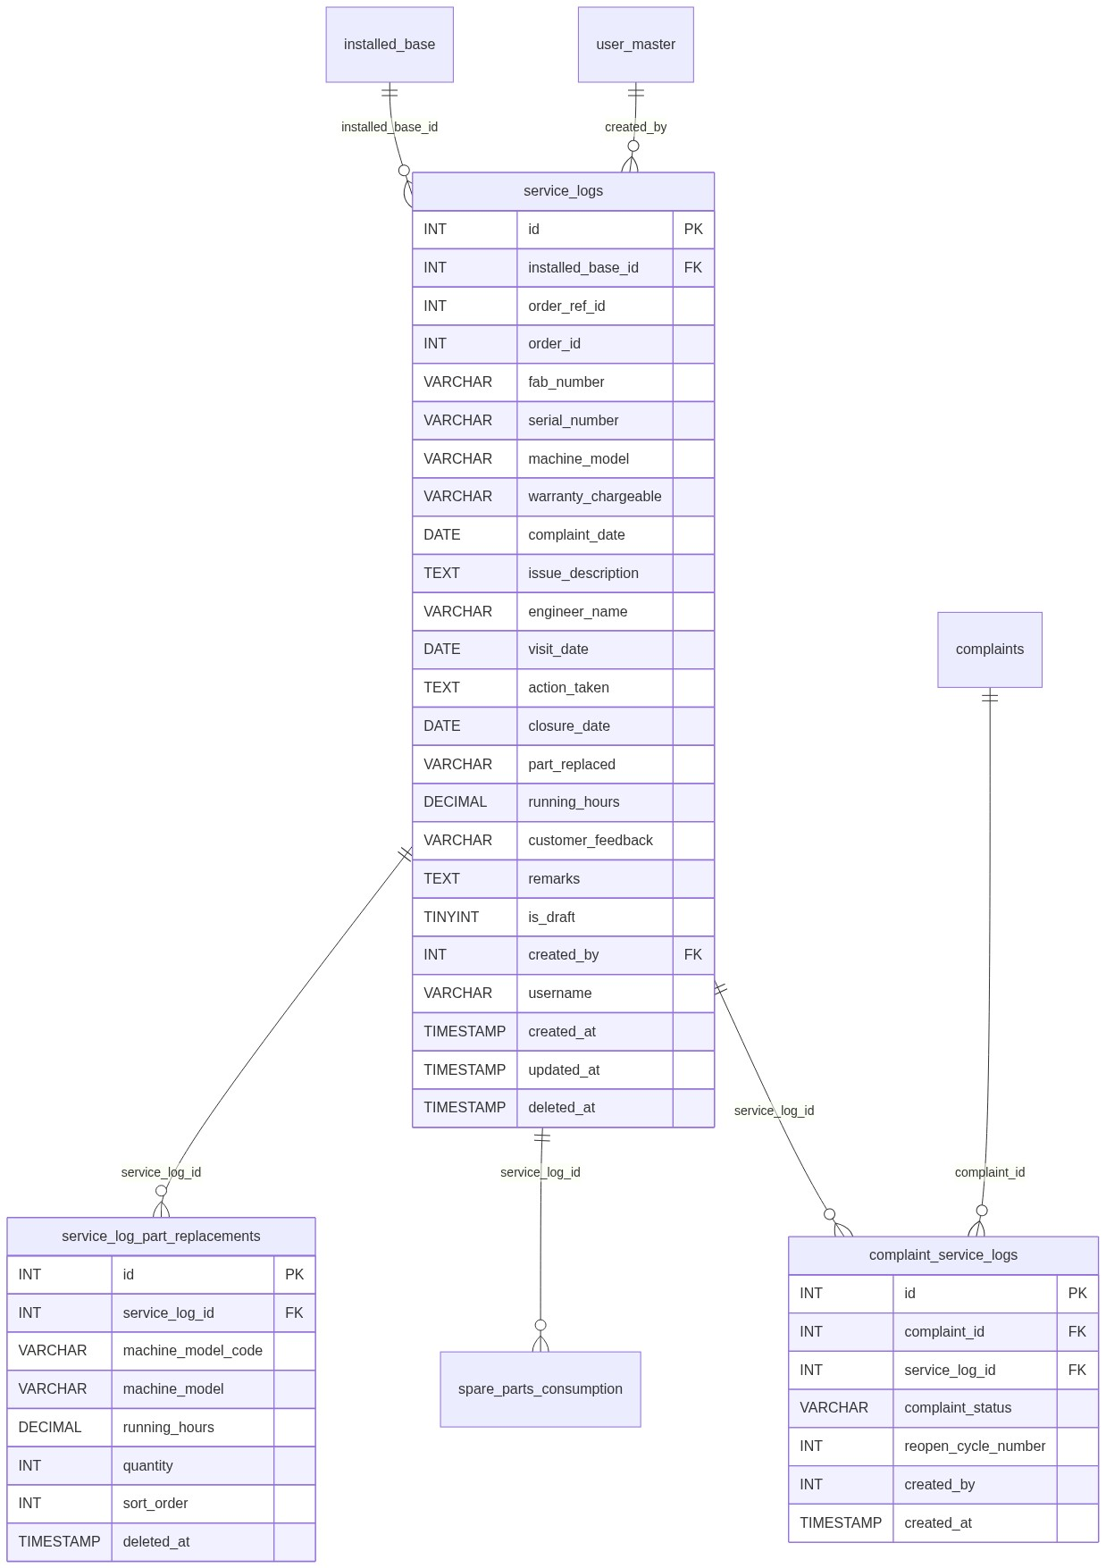
Figure 2 — Entity relationship diagram

5.2 Table: service_logs
Column | MySQL type | Null | Default | Description
id | INT UNSIGNED AUTO_INCREMENT | NO | — | PK
installed_base_id | INT UNSIGNED | NO | — | FK → installed_base.id
order_ref_id | INT | YES | 0 | Legacy; saved as 0
order_id | INT / VARCHAR(50) | YES | 0 | Legacy; saved as 0
fab_number | VARCHAR(100) | NO | — | Must match IB
serial_number | VARCHAR(10) | NO | — | Auto 10001–99999
machine_model | VARCHAR(255) | NO | — | From IB
warranty_chargeable | VARCHAR(150) | NO | — | SCM option
complaint_date | DATE | NO | — | Log Date
issue_description | TEXT | NO | —
engineer_name | VARCHAR(150) | NO | — | Alpha + spaces
visit_date | DATE | NO | —
action_taken | TEXT | NO | —
closure_date | DATE | YES | NULL | Required on final submit
part_replaced | VARCHAR(50) | NO | — | SCM Yes/No etc.
running_hours | DECIMAL(12,2) | YES | NULL | Required if Part Replaced Yes
customer_feedback | VARCHAR(10) | YES | NULL | "1"–"10"
remarks | VARCHAR(1000) | YES | NULL
separator_remaining_date | DATE | YES | NULL | Consumable
separator_remaining_hours | DECIMAL(12,2) | YES | NULL
air_filter_remaining_date | DATE | YES | NULL
air_filter_remaining_hours | DECIMAL(12,2) | YES | NULL
oil_filter_remaining_date | DATE | YES | NULL
oil_filter_remaining_hours | DECIMAL(12,2) | YES | NULL
oil_remaining_date | DATE | YES | NULL
oil_remaining_hours | DECIMAL(12,2) | YES | NULL
valve_kit_remaining_date | DATE | YES | NULL
valve_kit_remaining_hours | DECIMAL(12,2) | YES | NULL
grease_remaining_date | DATE | YES | NULL
grease_remaining_hours | DECIMAL(12,2) | YES | NULL
is_draft | TINYINT(1) | NO | 0 | 1 = draft
created_by | INT UNSIGNED | NO | — | FK → user_master.id
username | VARCHAR(100) | NO | — | Scope / ownership
created_at | TIMESTAMP | NO | CURRENT_TIMESTAMP
updated_at | TIMESTAMP | YES | NULL | Update / soft-delete
deleted_at | TIMESTAMP | YES | NULL | Soft-delete

Recommended indexes: PRIMARY KEY (id), KEY idx_sl_ib (installed_base_id), KEY idx_sl_username (username), KEY idx_sl_deleted (deleted_at), KEY idx_sl_serial (serial_number), KEY idx_sl_draft (is_draft).

5.3 Related tables
Table | Relationship | Notes
installed_base | Parent via installed_base_id | Soft-delete independent
service_log_part_replacements | Child rows when Part Replaced = Yes | Soft-delete via deleted_at
spare_parts_consumption | Optional service_log_id | Created from SL row action
complaint_service_logs | Maps complaint cycle ↔ SL | Status + reopen_cycle_number
user_master | created_by | Actor
SCM option tables | Logical | warranty_chargeable, part_replaced

service_log_part_replacements
Column | MySQL type | Description
id | INT UNSIGNED AUTO_INCREMENT | PK
service_log_id | INT UNSIGNED | FK
machine_model_code | VARCHAR(100) | Part / model code
machine_model | VARCHAR(255) | Description
running_hours | DECIMAL(12,2) | Copied from common hours
quantity | INT | ≥ 1
sort_order | INT | Display order
deleted_at | TIMESTAMP NULL | Soft-delete

5.4 Reference / lookup sources
Source | Usage
installed_base (via api/installed_base_link_search.php) | Link Select2
System Config Master warranty_chargeable | Service type dropdown
System Config Master part_replaced | Yes/No dropdown
api/machine_model_search.php | Part-replacement rows
api/service_log_next_serial.php | Peek next serial
Complaint record + FAB → IB | Complaint prefill

────────────────────────────────

6. API / Backend Design

6.1 Page endpoints (HTML / form POST)
Endpoint | Method | Auth | Description
service_log.php | GET | view | Listing + form panel
service_log.php | POST submit_service_log | add / edit | Create or finalize/update
service_log.php | POST submit_service_log_draft | add / edit | Save / update draft
service_log_details.php?id= | GET | view + ACL | Details (id base64)
delete_service_log.php?id= | GET | delete + ACL | Soft-delete (id base64)

Deep-link draft edit:
service_log.php?edit_draft={base64(slId)}&return_ib={base64(ibId)}

Key POST fields
Field | Notes
record_id | 0 = create; >0 = update
installed_base_id, fab_number, machine_model | IB-linked
serial_number | Server-allocated on create
warranty_chargeable, complaint_date | Log date
issue_description, engineer_name, visit_date, action_taken, closure_date | Service details
part_replaced, running_hours, customer_feedback, remarks | Usage & feedback
part_replacement_multi | 1
part_replacement_entries[...] | Code, model, qty
*_remaining_date / *_remaining_hours | Six consumables
from_installed_base_modal / from_complaint_modal | Modal flags
return_installed_base_id | Redirect after save

6.2 JSON APIs

POST api/service_log_datatable.php
Scoped DataTables. Columns include id (draft badge), serial, machine model, warranty, engineer, visit/closure dates, created_at, actions.

GET api/service_log_get.php?id=
Full form payload + part_replacement_entries + is_draft.
Optional complaint_id for complaint-flow ACL.
Errors: Invalid record. / Record not found.

POST api/service_log_create.php
{ "success": true, "message": "...", "service_log_id": 1, "installed_base_id": 10 }
Messages vary by context (page / IB modal / complaint).

POST api/service_log_update.php
Same success shape; sets is_draft = 0 on final update path.

GET api/service_log_next_serial.php
Returns next serial peek for UI.

GET api/installed_base_service_log_prefill.php?id=
{
"installed_base_id": 1,
"installed_base_label": "#1 - FAB - Customer",
"order_id": "",
"fab_number": "...",
"machine_model": "CODE - DESC",
"machine_model_code": "...",
"machine_model_desc": "...",
"running_hours": "...",
"serial_number": "10042"
}

POST api/installed_base_service_log_draft_create.php
Draft create from IB modal (from_installed_base_modal=1).

GET api/service_log_spare_parts_prefill.php?id=
Prefills Add Spare Parts; running hours = SL hours, else IB hours.

Complaint APIs
API | Purpose
GET api/complaint_service_log_prefill.php?complaint_id= | Prefill + cycle metadata
POST api/complaint_service_log_draft_save.php | Draft + mapping row
GET api/complaint_service_log_summary.php?complaint_id= | Cycle summary / permissions

6.3 Supporting lookup APIs
API | Purpose
api/installed_base_link_search.php | IB Select2 on SL form
api/machine_model_search.php | Part-replacement model Select2
api/service_log_link_search.php | SL picker (Spare Parts page)
api/spare_parts_create.php | Create spare parts from SL modal

6.4 Core PHP module responsibilities
Module / file | Responsibility
includes/service_log_helpers.php | from_post, validate, create/update, serial alloc, part replacements, actions HTML
includes/service_log_draft_helpers.php | Draft validate/save, badges, IB return URLs
includes/after_market_access_helpers.php | Scope, ACL, add-SL / spare-parts gates
includes/customer_feedback_rating_helpers.php | 1–10 rating validate/render
includes/complaint_service_log_helpers.php | Mapping, prefill, cycle rules
includes/rbac_* | Page/API guards

────────────────────────────────

7. Validation Rules

7.1 Server-side

Final submit (service_log_validate)
Field / rule | Error message
Installed Base | Installed base record is required.
FAB | Fab Number is required. / Fab Number does not match the selected installed base record.
Serial (update) | Serial Number is required.
Machine Model | Machine Model is required.
Warranty | Warranty / Chargeable is required. / Invalid Warranty / Chargeable selection.
Log Date | Log Date is required.
Issue | Issue / Service Description is required.
Engineer | Engineer Name is required. / alpha-spaces / max 150
Visit Date | Visit Date is required.
Action Taken | Action Taken is required.
Closure Date | Closure Date is required to complete the service log.
Part Replaced | Part Replaced is required. / Invalid Part Replaced selection.
Running Hours (Yes) | Running Hours is required. / Running Hours must be greater than 0.
Part rows (Yes) | At least one entry; entry N model/qty messages
Feedback (Yes) | Customer Feedback is required. / Please select a customer feedback rating between 1 and 10.
Remarks | Remarks cannot exceed 1000 characters.
Date order | Visit ≥ Log; Closure ≥ Visit
Remaining | {Label} Remaining Date/Hours is required. / hours non-negative
IB access | Selected installed base record was not found or is not assigned to your account.
Serial alloc | Unable to allocate a unique service log serial number.

Draft (service_log_validate_draft)
Same core required fields except Closure Date and remaining dates; remaining hours only if filled; feedback optional but must be 1–10 if set; part qty validated when filled.

7.2 Client-side
Script | Behavior
js/service_log_validation.js | Mirrors final submit (validate.js); messages often without trailing period
js/service_log_draft_validation.js | Draft rules; closure/remaining dates not required
js/service_log_part_replacement.js | Part rows + running hours + feedback when Yes
IB / complaint modal JS | Parallel constraints for modal forms

────────────────────────────────

8. UI Screen Specifications

8.1 Listing — service_log.php
Element | Spec
Title | Service Log Capture
Subtitle | Capture service visit and resolution details linked to installed base
Primary CTA | New Record (if add) → opens form panel
Grid columns | ID (draft badge), Serial No., Machine Model, Service Type, Engineer, Visit Date, Closure Date, Created At, Action
Empty | No service logs found. / No matching service logs found.
Draft rows | CSS class service-log-draft-row
Row actions | View, Edit, Add Spare Parts, Delete (permission-gated)

8.2 Form panel — #serviceLogForm
Section 1 — Machine & Order
Field | Control | Notes
Installed Base | Select2 | Required
Fab Number | readonly | From IB
Machine Model | readonly | From IB
Serial Number | readonly | Auto
Warranty / Chargeable | static Select2 | Required
Log Date | date (complaint_date) | Required
Order ID | hidden | Saved as 0

Section 2 — Issue / Services
Issue Description*, Engineer*, Visit Date*, Closure Date* (final), Action Taken*
Section 3 — Usage & Feedback
Part Replaced*; if Yes → Running Hours*, multi part rows (Machine Model/Part Select2, Qty*), Customer Feedback 1–10*, Remarks
Section 4 — Remaining Consumables
Six parts × Remaining Date + Remaining Hours (required on final)
Actions: Cancel · Save as Draft · Submit / Update Service Log
Hint: Closure date is mandatory to complete the service log.

8.3 Details — service_log_details.php
• Same four sections (read-only)
• Part Replaced Details only if Yes
• Optional linked complaint section
• Draft badge when is_draft = 1
• Back to Service Log Capture

8.4 Modals (from listing / related pages)
Modal | Host | Behavior
Add Spare Parts | SL listing / details | data-prefill="service_log" → spare parts prefill + create
Add Service Log | Installed Base listing | Prefill IB; create or draft; redirect ?service_log_added=1 / ?service_log_draft_added=1
Add Service Log | Complaint Service Update | Prefill by complaint; cycle mapping; draft/create APIs

────────────────────────────────

9. Database Flow

9.1 Create
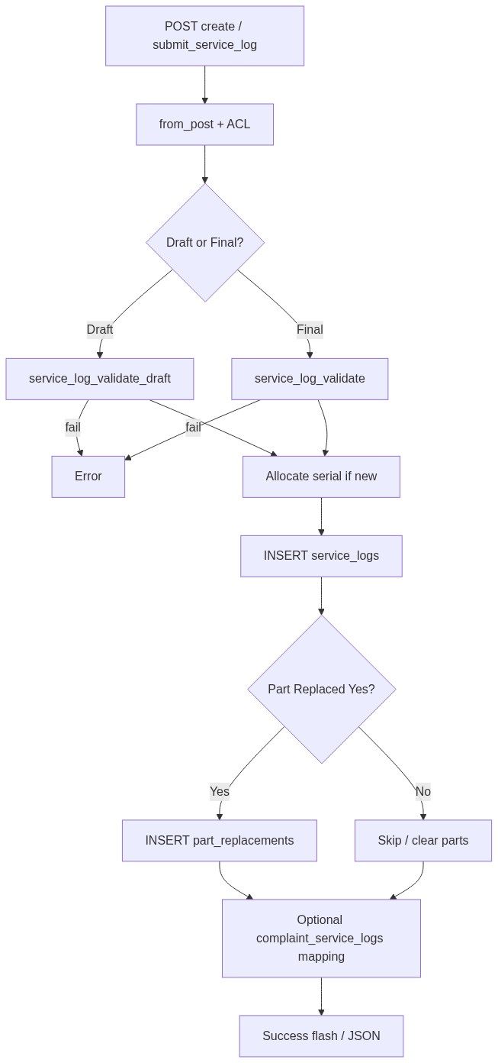
Figure 3 — Create database flow

9.2 Soft-delete
UPDATE service_logs
SET deleted_at = CURRENT_TIMESTAMP,
updated_at = CURRENT_TIMESTAMP
WHERE id = :id
AND deleted_at IS NULL;
Confirm UI: Delete this service log?
Does not cascade to service_log_part_replacements or spare_parts_consumption.

9.3 List query pattern
SELECT ... FROM service_logs
WHERE /* after_market_list_scope: deleted_at IS NULL [AND username ...] */
AND /* optional DataTables search */
ORDER BY {col} {ASC|DESC}
LIMIT :limit OFFSET :offset;
Draft indicator: is_draft = 1 rendered as badge in ID column.
────────────────────────────────

10. Sequence Diagram

10.1 Create / update service log
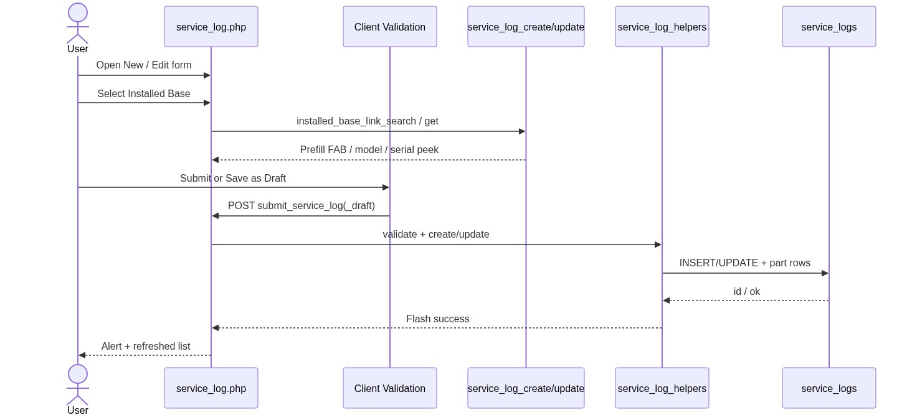
Figure 4 — Sequence: Create / update service log

10.2 Add Spare Parts from Service Log row
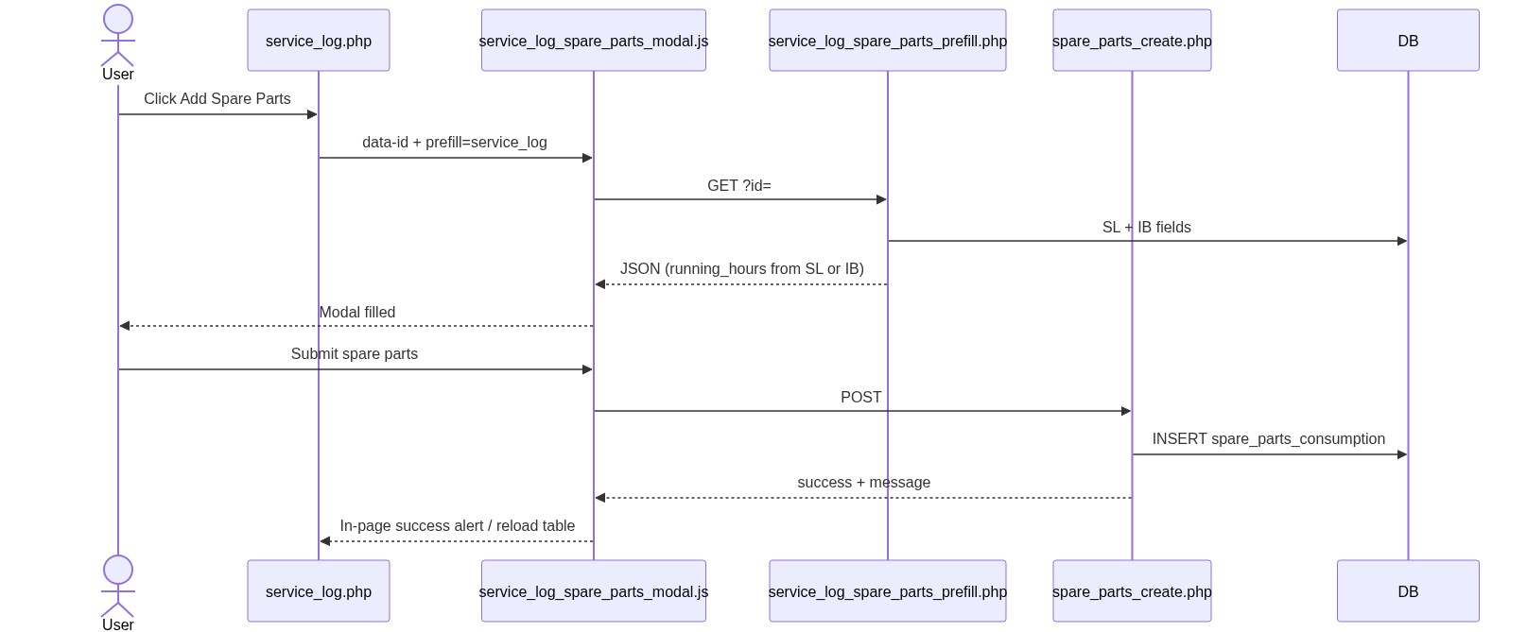
Figure 5 — Sequence: Add Spare Parts from Service Log
────────────────────────────────

11. Activity Diagram
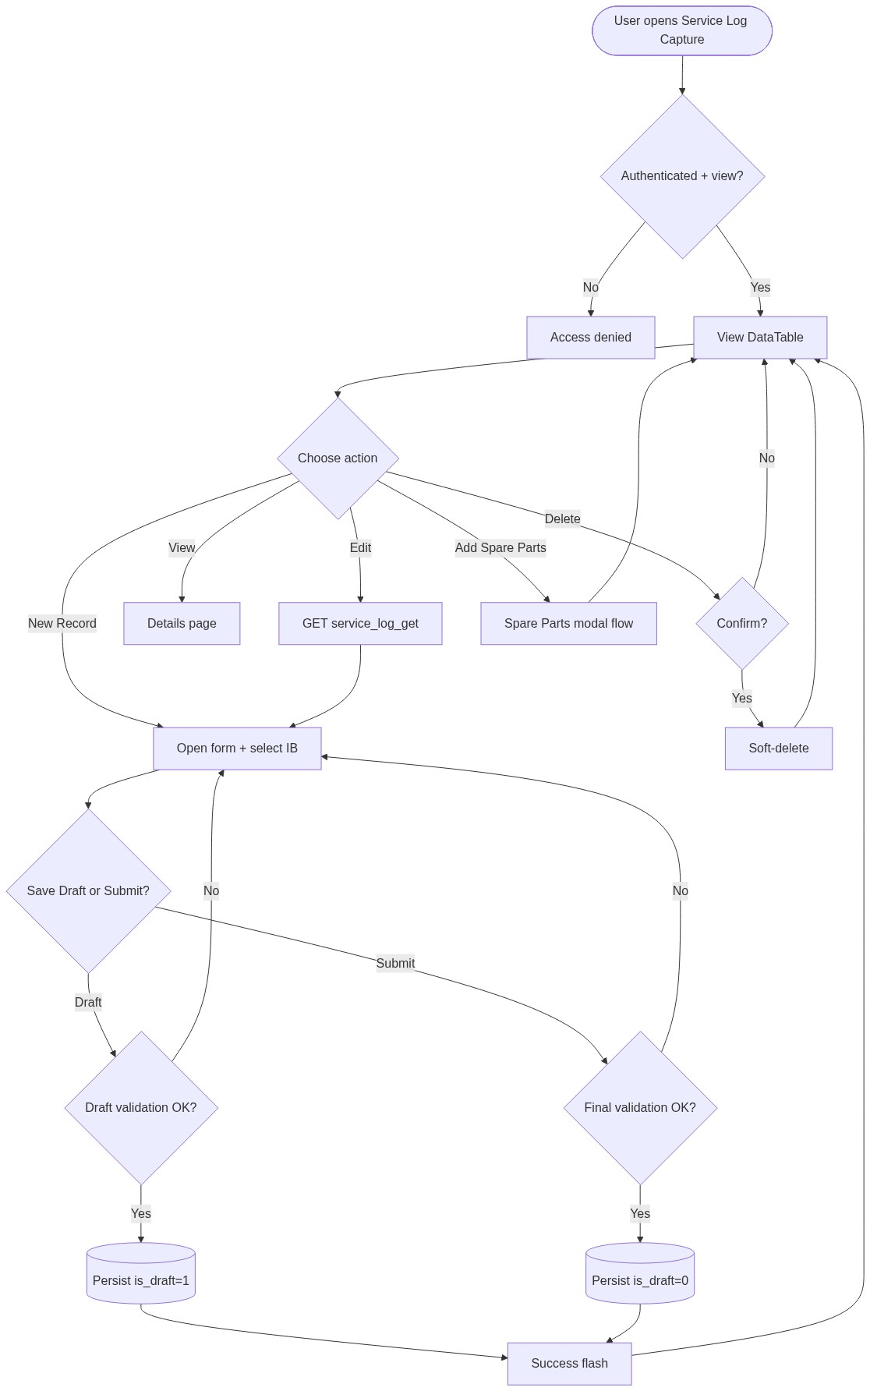
Figure 6 — Activity diagram
────────────────────────────────

12. Class / Module Diagram
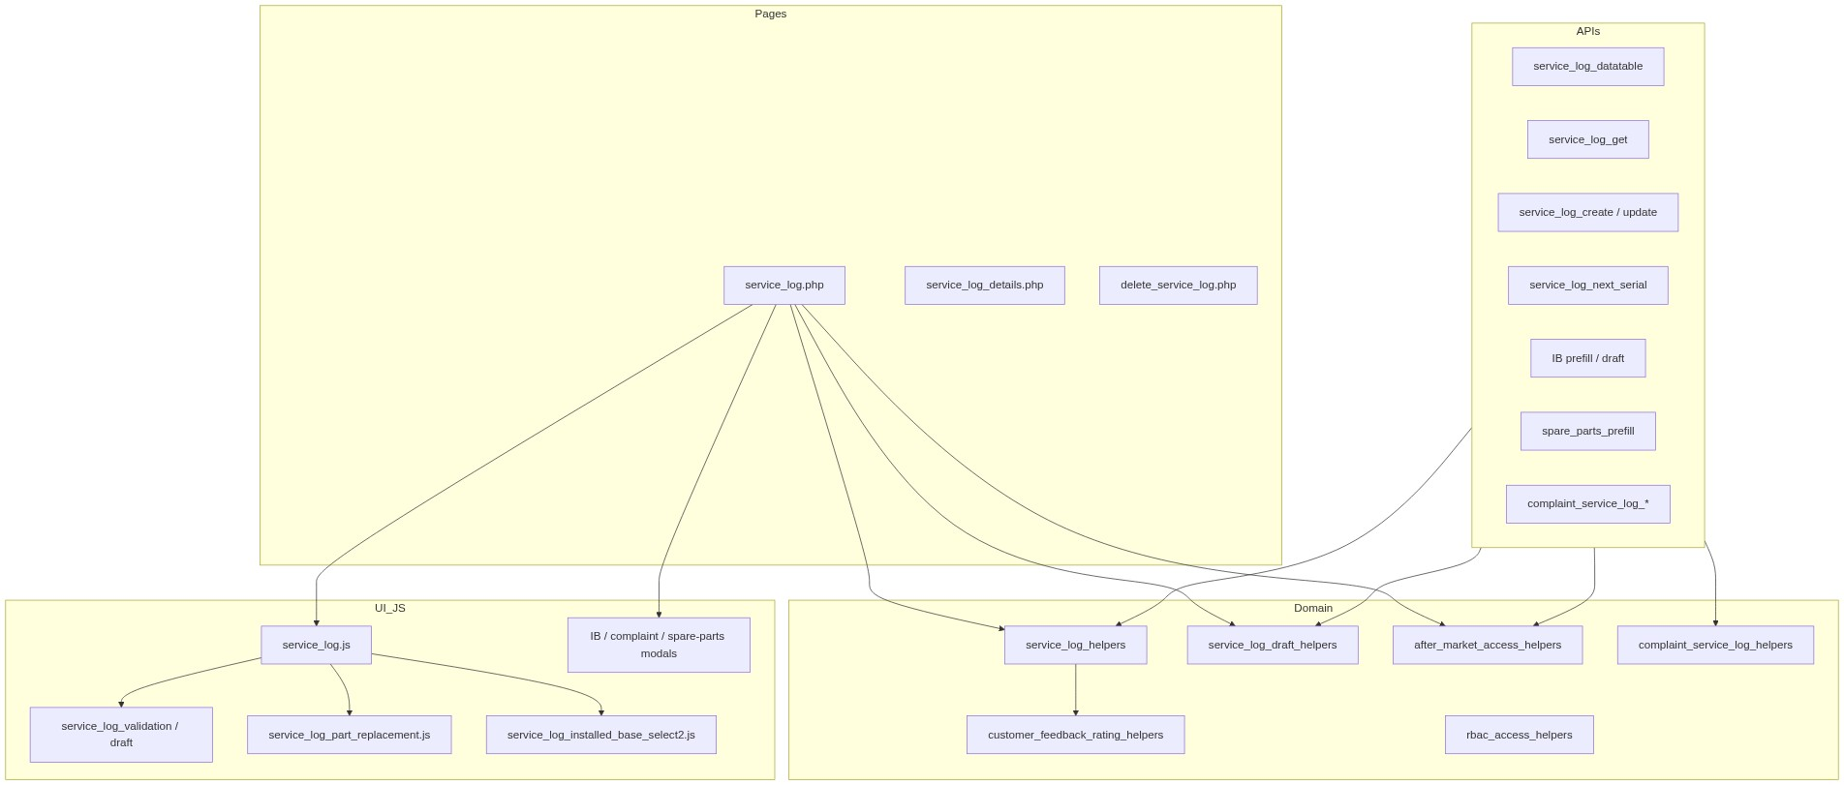
Figure 7 — Class / module diagram

12.1 Key functions
Function / area | Role
service_log_from_post() | Map POST → data
service_log_validate() / service_log_validate_draft() | Server validation
service_log_create_record() / service_log_update_record() | Persist final
service_log_save_draft_record() | Persist draft
service_log_allocate_serial() / next-serial peek | Serial 10001–99999
service_log_insert/sync_part_replacements() | Child parts
service_log_apply_part_replacement_fields_for_save() | Yes/No field rules
service_log_entry_actions() | Row action HTML
after_market_list_scope() / after_market_user_can_access_record() | ACL
Complaint mapping helpers | Cycle link + prefill

────────────────────────────────

13. Folder Structure
ComplaintManagement/
├── service_log.php
├── service_log_details.php
├── delete_service_log.php
├── api/
│ ├── service_log_datatable.php
│ ├── service_log_get.php
│ ├── service_log_create.php
│ ├── service_log_update.php
│ ├── service_log_next_serial.php
│ ├── service_log_link_search.php
│ ├── service_log_spare_parts_prefill.php
│ ├── installed_base_service_log_prefill.php
│ ├── installed_base_service_log_draft_create.php
│ ├── complaint_service_log_prefill.php
│ ├── complaint_service_log_draft_save.php
│ └── complaint_service_log_summary.php
├── includes/
│ ├── service_log_helpers.php
│ ├── service_log_draft_helpers.php
│ ├── service_log_record_details_section.php
│ ├── service_log_linked_complaint_details_section.php
│ ├── service_log_spare_parts_modal.php
│ ├── installed_base_service_log_modal.php
│ ├── complaint_service_log_helpers.php
│ ├── complaint_service_log_draft_helpers.php
│ ├── complaint_service_log_modal.php
│ ├── after_market_access_helpers.php
│ └── customer_feedback_rating_helpers.php
├── js/
│ ├── service_log.js
│ ├── service_log_validation.js
│ ├── service_log_draft_validation.js
│ ├── service_log_part_replacement.js
│ ├── service_log_installed_base_select2.js
│ ├── service_log_spare_parts_modal.js
│ ├── installed_base_service_log_modal.js
│ ├── installed_base_service_log_draft.js
│ ├── complaint_service_log_modal.js
│ └── complaint_service_log_draft.js
└── docs/
└── LLD_Service_Log_Capture_Module.md
────────────────────────────────

14. Error Handling
Layer | Pattern
Page POST | $error_message / $success_message alerts
Delete / ACL | $_SESSION['error_message'] + redirect
JSON APIs | HTTP 401 / 403 / 404 / 405 / 422 + {"error":"..."}
Client AJAX | alert() or in-page Bootstrap alerts
DB | PDO exceptions → user-safe message

14.1 Common messages
Message | When
Access denied. You do not have permission for this action. | RBAC / ACL
Access denied. You do not have permission to add/edit service log records. | Add/edit gate
Unable to resolve logged-in user. | Missing user id
Record not found or already deleted. | Missing target
Failed to save service log. / Failed to update service log. / Failed to save service log draft. | Persist failure
Failed to delete service log. | Soft-delete failure
Only draft service logs can be saved as draft. | Re-draft non-draft
Service Log Capture must create a new record. | IB modal with existing record_id
No installed base record found for this complaint Fab Number. | Complaint prefill
A service log already exists for the {status} cycle... | Duplicate cycle SL
Please complete the service log before submitting the service update. | Complaint gate

────────────────────────────────

15. Security Considerations
Area | Control
SQL Injection | PDO prepared statements / bindValue
XSS | htmlspecialchars on output; careful action HTML builders
CSRF | Session-authenticated POST; recommend CSRF tokens on mutating forms/APIs
Authentication | Portal session
Authorization | RBAC + after-market scope + record ACL
IDOR | Details/delete/get scoped; base64 IDs are obfuscation only
Soft-delete | All reads filter deleted_at IS NULL
Serial allocation | Advisory lock to avoid races
Mass assignment | Explicit from_post whitelist; order fields forced to 0

────────────────────────────────

16. Audit Logs

16.1 Built-in field-level audit
Field | Behavior
created_by | Set on INSERT
username | Set on INSERT (list scope)
created_at | DB default
updated_at | Set on UPDATE and soft-delete
deleted_at | Soft-delete timestamp
is_draft | Draft vs final state
updated_by | Not implemented

No dedicated service_log_audit_log table in the current codebase. Recommended future enhancement: action + before/after JSON + actor + IP (same pattern as Installed Base LLD §16.2).
────────────────────────────────

17. Test Cases

17.1 Functional
ID | Scenario | Expected
TC-01 | User with view opens listing | Scoped DataTable loads
TC-02 | Create with valid IB + final fields | Success; is_draft=0; serial assigned
TC-03 | Save as Draft without closure | Success; is_draft=1; draft badge
TC-04 | Submit draft with closure + consumables | Becomes final is_draft=0
TC-05 | FAB mismatch vs IB | Error: FAB does not match
TC-06 | Part Replaced Yes without part rows | Validation error
TC-07 | Part Replaced Yes without feedback (final) | Validation error
TC-08 | Part Replaced No | Hours/feedback/parts cleared on save
TC-09 | Visit before Log Date | Validation error
TC-10 | Soft-delete | Removed from list; deleted_at set
TC-11 | Edit accessible record | Update success
TC-12 | Add Spare Parts from row | Modal prefills; create succeeds
TC-13 | IB modal create | Redirect service_log_added=1
TC-14 | IB modal draft | Redirect service_log_draft_added=1
TC-15 | Complaint: no IB for FAB | Prefill error message
TC-16 | Complaint: duplicate cycle SL | Blocked with cycle message
TC-17 | Sales coordinator scope | Sees only assigned usernames
TC-18 | Admin list | Sees all active logs
TC-19 | Remaining hours missing on final | Validation error
TC-20 | Serial not editable by user | Remains server value on update

────────────────────────────────

18. Assumptions & Dependencies

18.1 Assumptions
1. Users authenticate via existing portal session (user_master).
2. RBAC permissions for service-log-capture (and cross-module add-SL / spare-parts) are seeded.
3. An Installed Base record already exists before a Service Log can be created.
4. SCM masters for warranty_chargeable and part_replaced are maintained.
5. Soft-deleted children (parts / spare parts) are filtered independently.
6. Order linkage is intentionally disabled in UI.
7. Document target stack is Core PHP + MySQL; this repository currently runs PostgreSQL with equivalent PDO SQL.

18.2 Dependencies
Dependency | Purpose
PHP PDO + MySQL (or PostgreSQL) | Persistence
Session + RBAC helpers | AuthZ
Installed Base module | Parent machine record
jQuery + Select2 + DataTables + Bootstrap | UI
validate.js | Client validation
Spare Parts module | Child consumption from SL
Complaints / Service Update | Optional cycle coupling
current_username_helpers | Actor identity
Customer feedback rating helpers | 1–10 UI/validation

────────────────────────────────

Appendix A — Success flash query flags
Flag / source | Message
Page create | Service log saved successfully.
Page update | Service log updated successfully.
Page/API draft create | Service log saved as draft successfully.
Page/API draft update | Service log draft updated successfully.
IB modal create / ?service_log_added=1 | Service Log Capture added successfully.
IB modal draft / ?service_log_draft_added=1 | Service log saved as draft successfully.
IB details ?service_log_updated=1 | Service log updated successfully.
IB details ?service_log_draft_updated=1 | Service log draft updated successfully.
Complaint create | Service log added successfully.
Delete (session) | Service log deleted successfully.

────────────────────────────────

Appendix B — Select2 control map
Control | Element / context | API / mode
Installed Base | #installedBaseLinkSelect | api/installed_base_link_search.php
Warranty / Chargeable | #serviceLogWarrantySelect | Static SCM options
Part Replaced | #serviceLogPartReplacedSelect | Static SCM options
Part row Machine Model/Part | Part replacement entries | api/machine_model_search.php
IB / complaint modal machine parts | Modal forms | api/machine_model_search.php
Spare Parts page → Service Log | #sparePartsServiceLogSelect | api/service_log_link_search.php
Link search label format | — | #id - {serial} - Visit: {visit_date}

────────────────────────────────
End of LLD — Service Log Capture Module

